Spring program to create a web application of spring Boot using eclipse IDE.
Problem Statement : display using Spring Boot.

Creating a Spring Boot Project
Following are the steps to create a simple Spring Boot Project.

Step 1: Start a new Spring Boot project
Use start.spring.io to create a “web” project. In the “Dependencies” dialog search for and add the “web” dependency as shown in the screenshot. Hit the “Generate” button, download the zip, and unpack it into a folder on your computer.
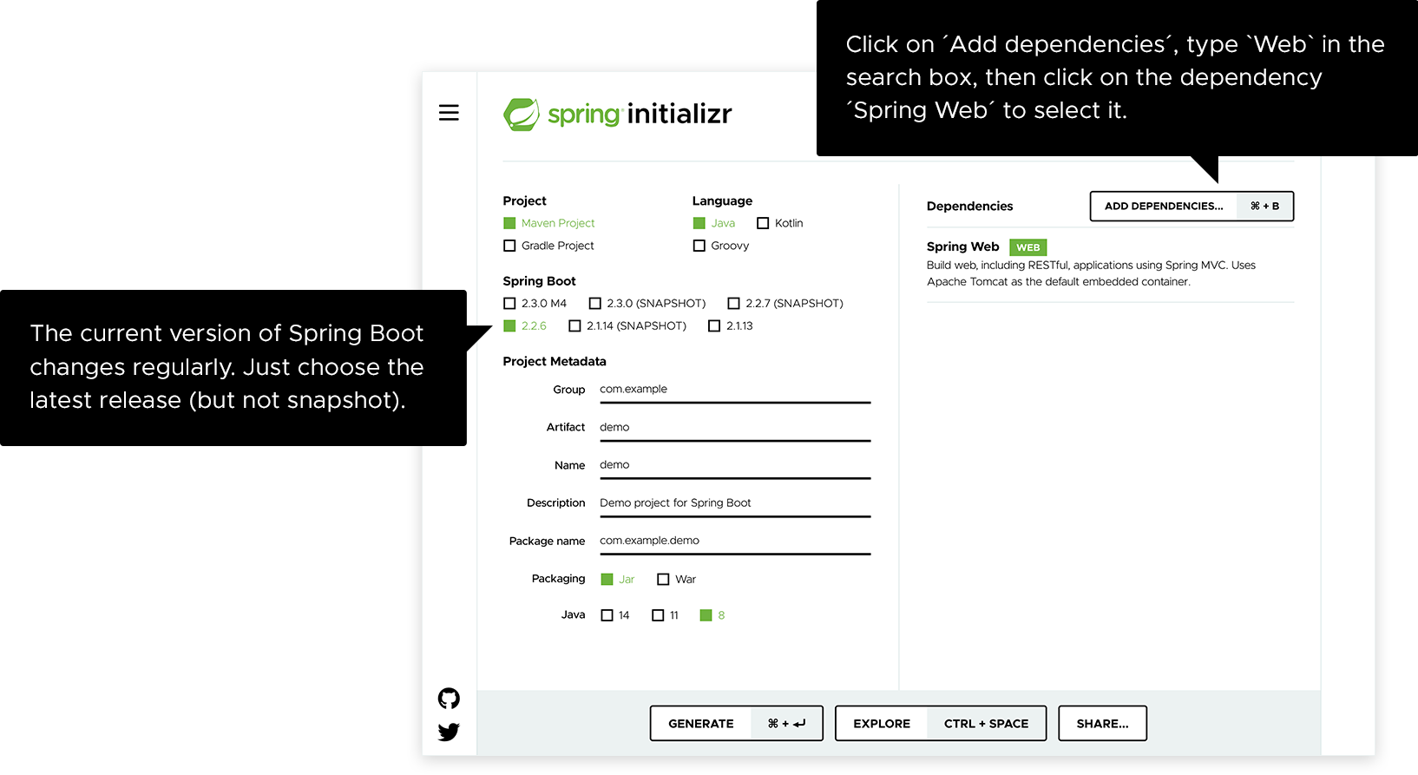
Projects created by start.spring.io contain Spring Boot , a framework that makes Spring ready to work inside your app, but without much code or configuration required. Spring Boot is the quickest and most popular way to start Spring projects.
Extract the RAR file.
Import the folder.
File -> Import -> Existing Maven Project -> Next -> Browse -> Select the project -> Finish
It takes some time to import the project. When the project imports successfully, we can see the project directory in the Package Explorer. The following image shows the project directory:

Step 2: Add your code
Open up the project in Eclipse IDE and locate the DemoApplication.java file in the src/main/java/com/example/demo folder.
copy and paste the code or just type it.
package com.example.demo;
import org.springframework.boot.SpringApplication;
import org.springframework.boot.autoconfigure.SpringBootApplication;
import org.springframework.web.bind.annotation.GetMapping;
import org.springframework.web.bind.annotation.RequestParam;
import org.springframework.web.bind.annotation.RestController;

@SpringBootApplication
@RestController
public class DemoApplication {
public static void main(String[] args) {
SpringApplication.run(DemoApplication.class, args);
}
@GetMapping("/hello")
public String hello(@RequestParam(value = "name", defaultValue = "World") String name) {
return String.format("Hello %s!", name);
}
}

Step 6: Run the DemoApplication.java file.
Right-click on the file -> Run As -> Java Applications
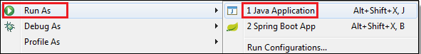
The following image shows the application runs successfully.
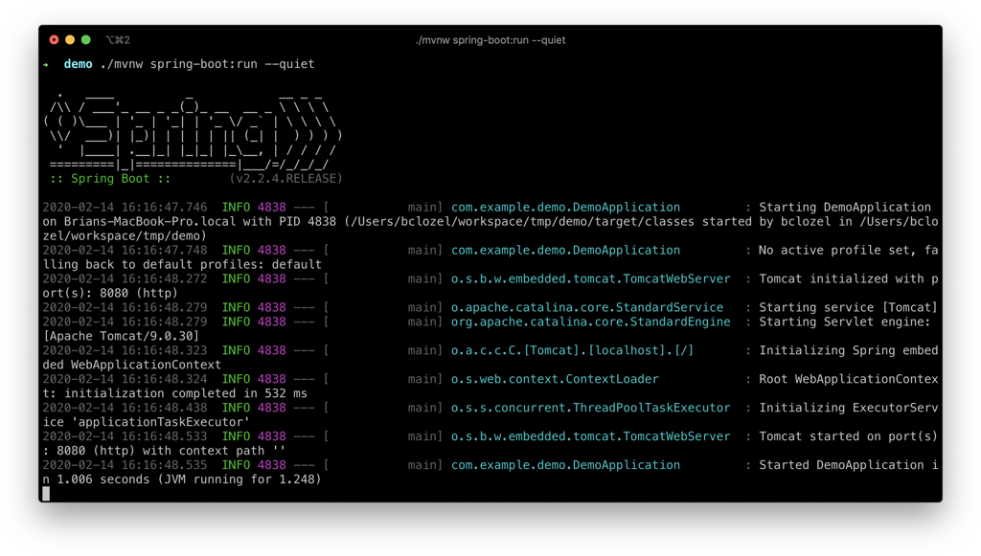
Open your browser and in the address bar at the top enter http://localhost:8080/hello
